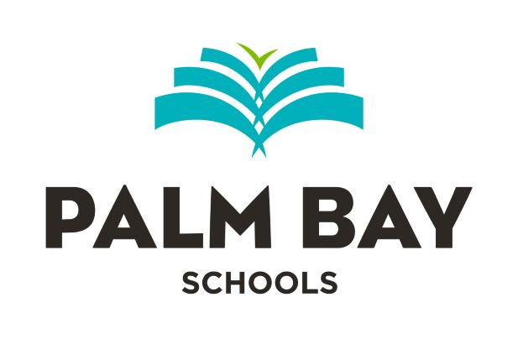

PUBLIC NOTICE

PALM BAY EDUCATION GROUP, INC.
WILL HAVE AN ORGANIZATIONAL BOARD MEETING ON
JULY 13, 2026
STARTING AT 12:00 NOON

